**Experiment No 12**

**Name: Arya Manoj Madhavi**

**Div: D15B**

**Roll No.:31**

**Batch B**

**AIM: To create a Lambda function which will log “An Image has been added” once you add an object to a specific bucket in S3**

**steps:**

**Open up the S3 Console and create a new bucket**

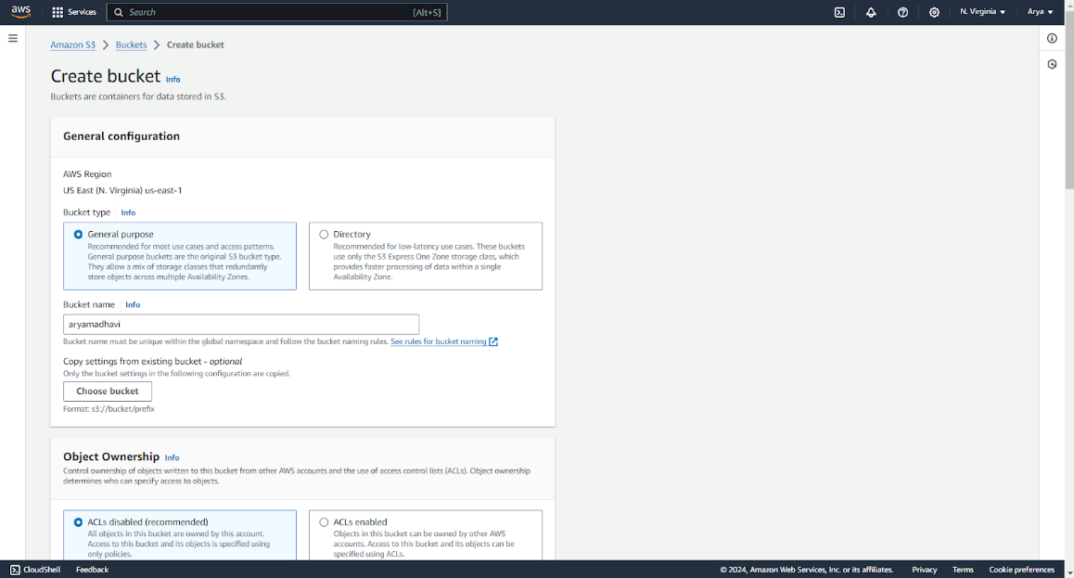

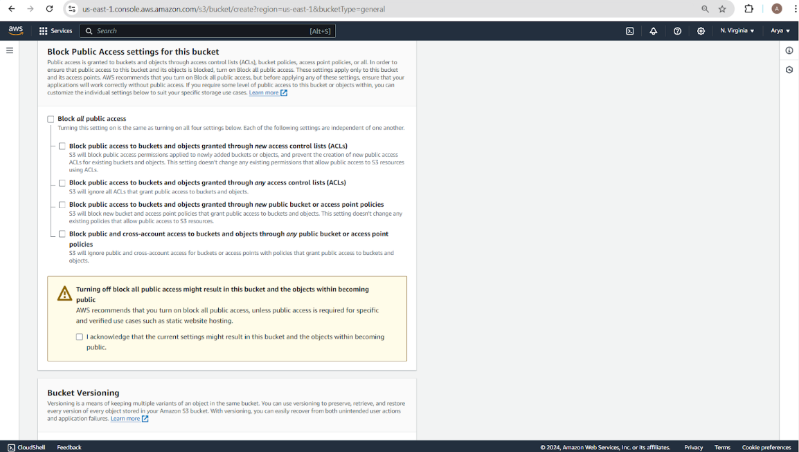

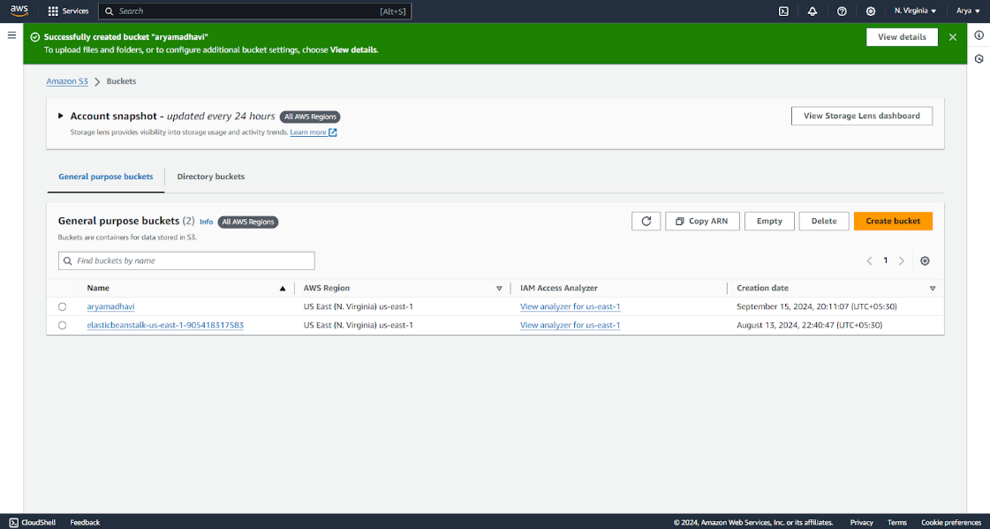

**Create Choose Lambda function as destination and choose your lambda function and save**

**the changes.**

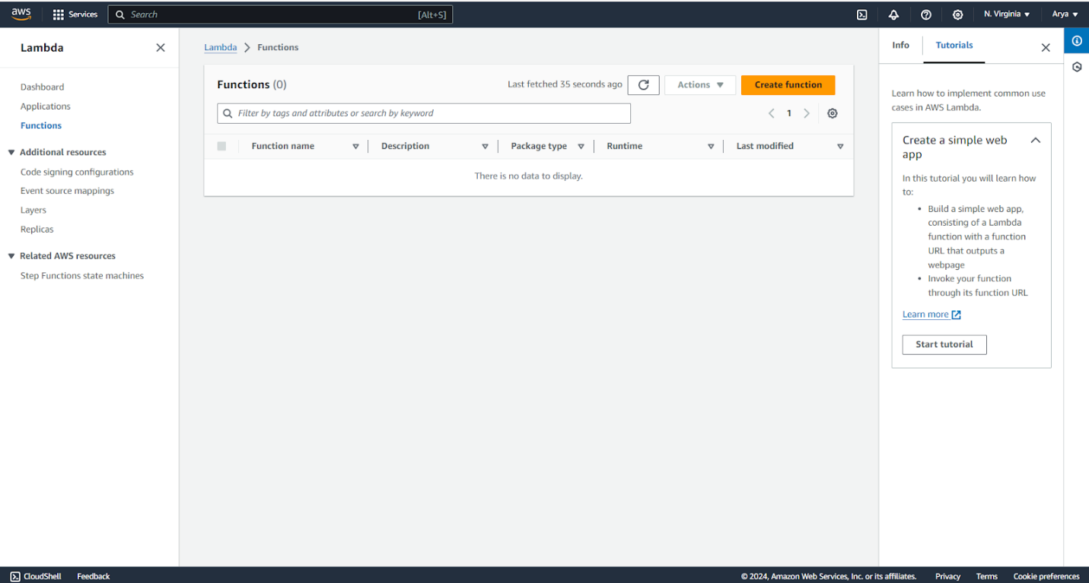

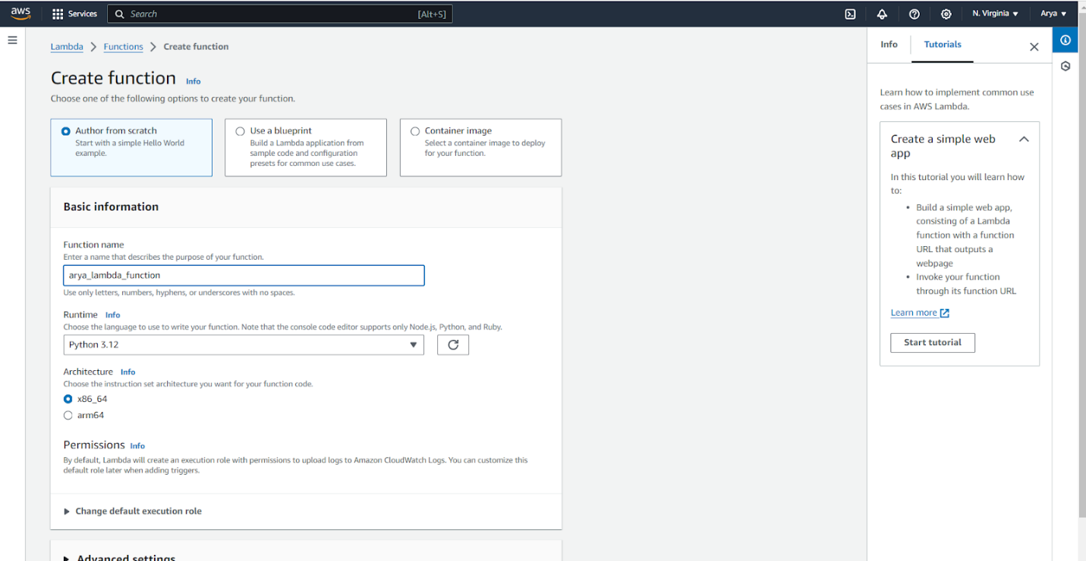

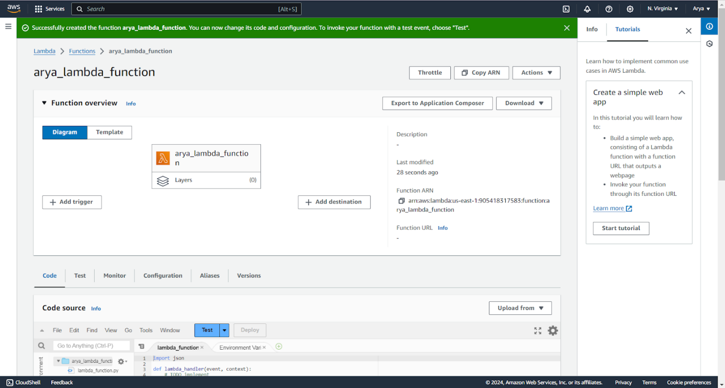

**Updated the function**

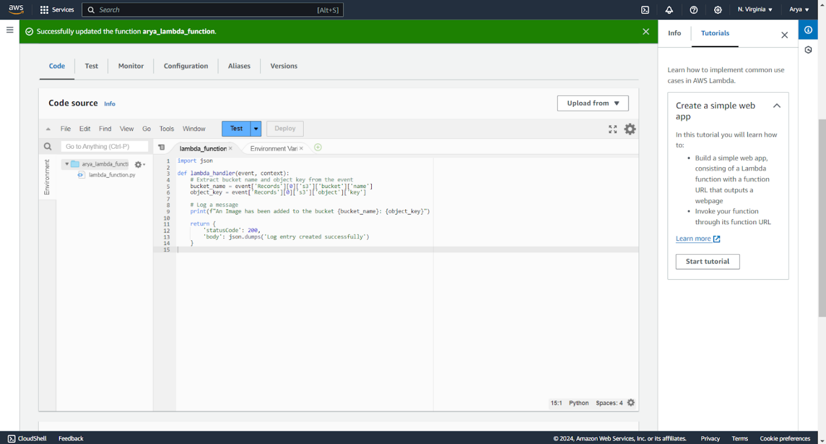

**Add trigger**

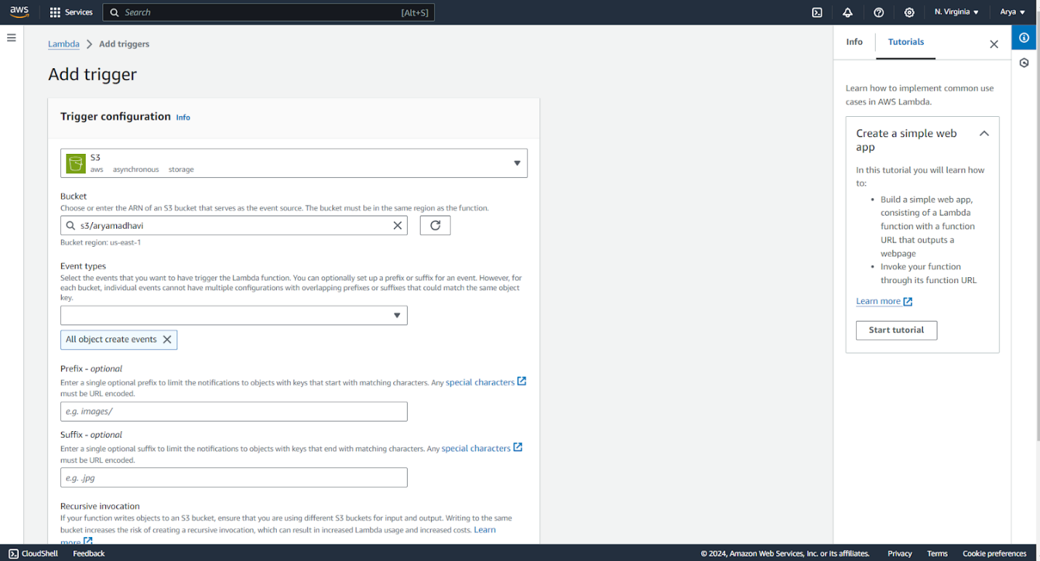

**Uploading files and folders**

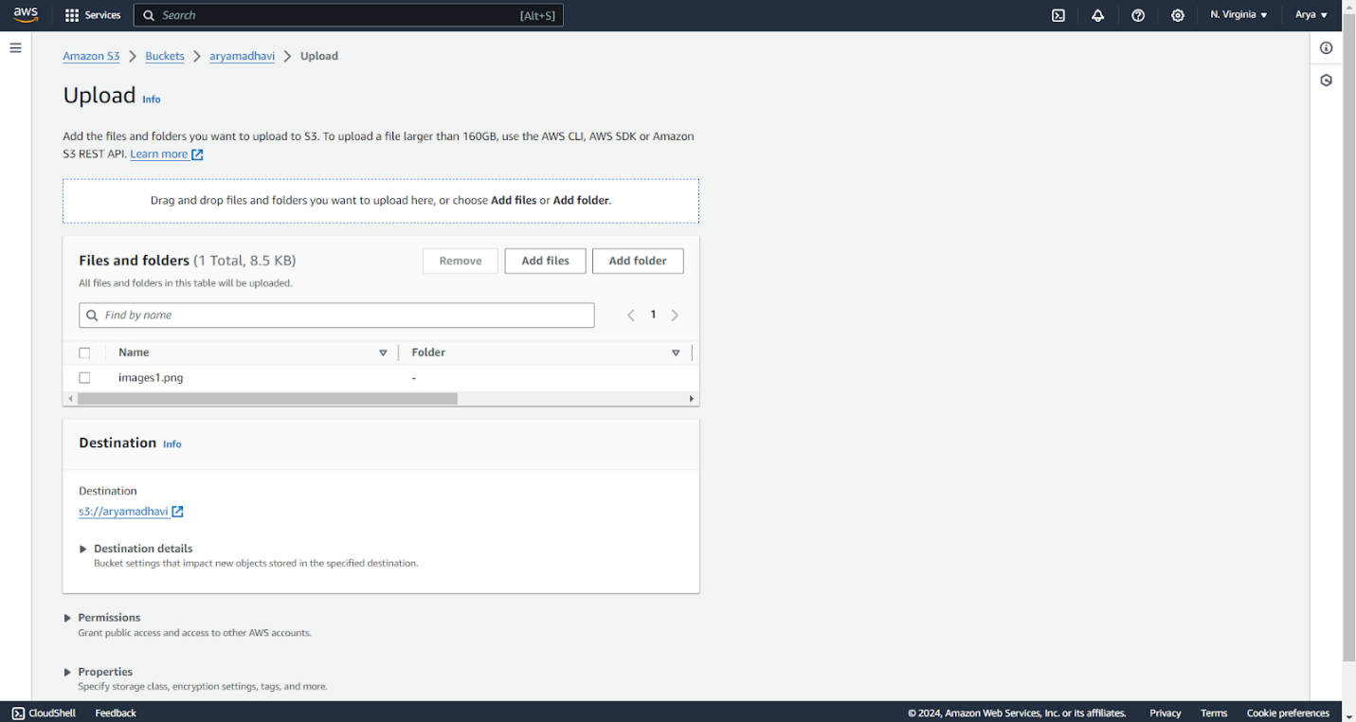

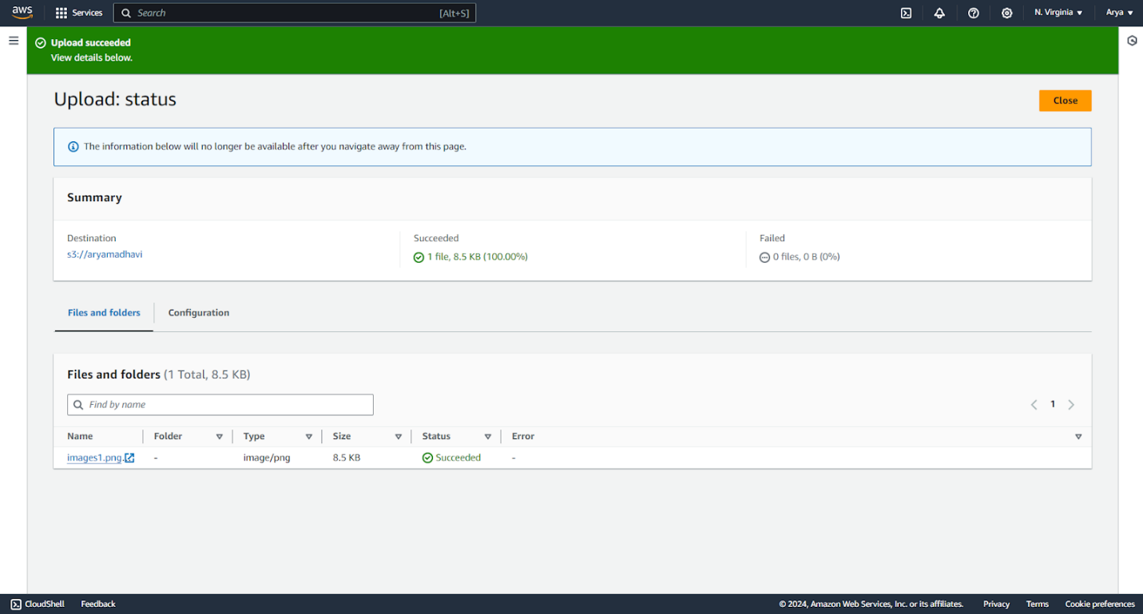

**Go to the "Monitoring" tab in your Lambda function to check the logs. Use CloudWatch Logs to view the output and confirm that the message "An Image has been added" has been logged.**

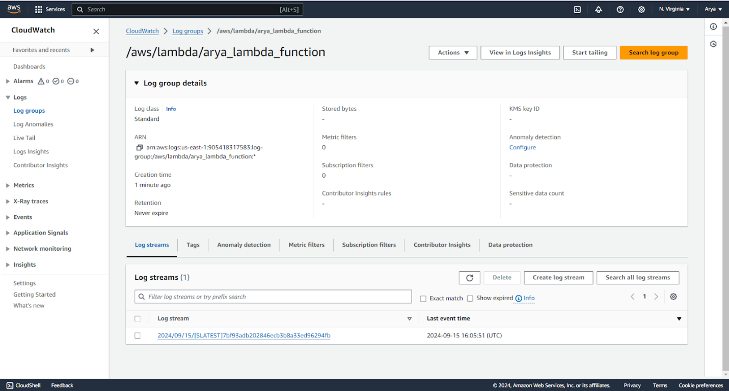

**Click on this log Stream that was created to view what was logged by**

**your function.**

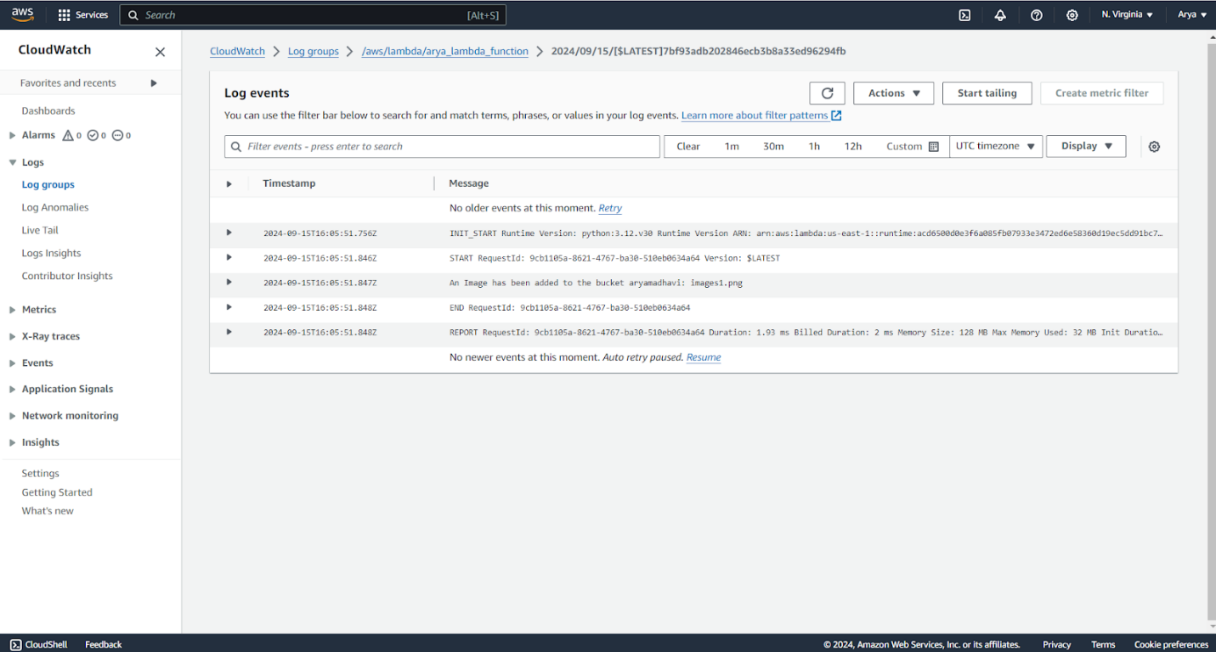

**Conclusion:**

Thus, we have successfully created an AWS Lambda function that logs “An Image has been added” whenever an object is added to a specific S3 bucket. This demonstrates the power of event-driven architecture, enabling automated actions in response to changes in cloud storage without the need for manual intervention.